© BranMark Strategy Group 2009

Case Study

LOWERING SALES COSTS BY $2 MILLION WHILE IMPROVING CUSTOMER RELATIONSHIPS A Sales Force Approach for Large Accounts

With the goal to better serve large, key accounts, and potentially do this more cost effectively, a manufacturer of industrial consumables asked BranMark’s consulting professionals to determine what could be done to restructure its sales force to be more efficient while not compromising customer service.

What The Manufacturer Was Facing
Three strategic factors were considered:
- All customers don’t want the same “services” from a sales force; and these customers’ expectations range from a “full service/consultative” need to a supplier who only has to provide “fast delivery and low price”
      - Most accounts are not easily, nor intuitively, assigned to a specific needs segment
      - A customer’s needs are likely to evolve
      - Who the decision maker is, and where that person is located, affects the approach to meeting customer requirements
- Yet the client’s organization and sales force had, for the most part, a homogeneous approach to selling and servicing customers
      - Resulting in some accounts being “over served” (which may be an annoyance) and result in excessive sales and support costs
      - While other accounts are “under served” creating competitor opportunities
- The client’s brand has three different positions depending upon the geography
      - In the US they are the market leader
      - In Canada the brand is a distant third
      - It had more recently been introduced in Europe, with rapid market share growth

Our Findings & Recommendations

With today’s pressures and demands, performance by the sales force can no longer be “bell shaped”; every sales person must be meeting and exceeding the sales goals. There is always planned turnover in a sales force. It use to be just the poorest performers who got fired, but nowadays even the average performers need to be addressed.
Overall, the study brought sales effectiveness back into focus for the manufacturer and caused both the sales people and their managers to challenge the needs and benefits of their day-to-day activities. They no longer take for granted that their communications are being received, nor that important information is being passed up, and along, their customers’ purchasing decision chains.
- Some key accounts who were being called on every 2-4 weeks now meet with manufacturer’s sales personnel 2-4 time a year
- In other account the sales force used to just call on purchasing, now they also regularly meet with the account’s engineers and production staff

$2 million in annual sales expense was saved was achieved from a $200K investment in sales forces effectiveness research and consulting. Plus incalculable account retention and improved customer satisfaction were seen.

Results, One Year Later
- The Canadian study saved about $1.1 million in annual sales expenses
- The effect of the US results were mostly in account retention than in sales force expense reductions
- The European study reduced operating costs by $0.9 million, through a combination of sales force and management expense reductions
- The unexpected benefit was that the streamlining of the sales force concept was extended to other departments/staffs

Sales Force Effectiveness Research
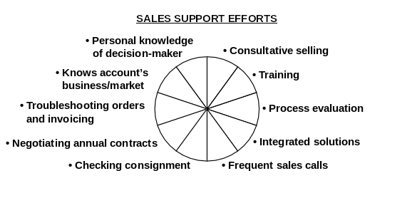
The service and support a sales person gives to customers may include the elements shown below. The key to an effective sales force is proportioning the activities to match the customer’s needs. When a sales force records how it spends it time across these elements and then the customers state their desired allocation, the two views seldom match—thereby providing the manufacturer with guidelines for restructuring.
?
?
?
?
?
?
?
?
?
?

In any b2b/industrial market, the customers’ needs/requirements of the vendor’s sales force can be related to other elements of the customer relationship. The level of importance wills very substantially driving customer segmentation and supplier programs, as depicted below.
Relative Value or Importance of the Various
Components of Purchasing Decisions

Customer-Needs Segmentation
High
Service
Demands
Relationship
Seekers
Drive
CUSTOMERS’ REQUIREMENTS GROUPS
Specialized &

Consultative

Needs

Convenience
& Low

Price

MANUFACTURER’S

SALES APPROACH &

& POSITIONING
Tech Support

Sales Support
Maintenance
Delivery
Price
Total Value = 100
RELATIVE VALUE OR IMPORTANCE OF THE
VARIOUS COMPONENTS OF PURCHASING DECISIONS
High Tech & High Touch
Rapid Repair & Maint-enance
Local Presence & Frequent Contact
Best Logistics & Low(est) Price
Sales force effectiveness is an integral part of an overall marketing strategy and when considered with other elements achieves not only an effective action plan but also a cost efficient one

